**PokerBots Course Notes**

**Florida International University**

**Competition Lecture 2 - Probability Fundamentals**

Contents

2.1 Pot Odds and Outs 2

2.2 Implied Odds 5

2.3 Board Texture Considerations 6

2.4 Ranges 6

2.5 Probability Foundations 8

2.6Kolmogorov Axioms 9

2.7 Random Variables and Distributions 11

2.9 Variance 11

2.10 Law of Large Numbers 12

2.11 Monte Carlo Simulation 12

**2.1 Pot Odds and Outs**

Defining Equity (P)

* At any point in the game there exists some fixed probability of winning, we call this Equity (P)
* In reality P is often hard to explicitly calculate, but we can reasonably estimate

**2.1.1 Expected Value**

* The notion of expected value (EV) is used to summarize distributions on real numbers by some representative value
* In short, “expected value” is just another way to say “mean”
* Finite events with equal probability → take the average
  + EV of dice roll: (1+2+3+4+5+6)/6 = 3.5
* What about events with different probabilities?
* Generalize to weighted average (weighted by probability)
  + X is a random variable with possible values in set S
  + E[X] = Σ s∈S s * P(X = s)
* For continuous distributions, this generalizes to an integral calculation

Expected Value

* Expected Value: how many chips we expect to win/lose on average
* EV of folding = 0 * pot_total - 0 * continue_cost = 0
* EV of calling a bet = P · pot_total − (1 − P) · continue_cost
* If P ≥ continue_cost / (pot_total + continue_cost), it is reasonable to call/bet.
* We call “continue_cost / (pot_total + continue_cost)” our Pot Odds.

Estimating Equity by Counting Outs

* Out = A card that would complete our hand or make us significantly stronger
* Idea: If we count our outs, we can estimate the probability of finding cards we need
* We can use this to estimate our probability of winning P

Strategy:

* Count the number of cards that complete our hand (outs)
* Multiply this number by 2 (1/52 cards gives ~2% chance of getting a specific

card)

* If we have two cards left to see (turn and river), multiply by 2.
* This number is our probability estimate! (as a percent)

Counting Outs Exercise

* How can we hit a straight?
  + Any Ace or Nine (8 outs)
  + Only 1 card left to come, so 1 * 8 * 2% = 16%
* How can we hit second pair?
  + Any Jack or Queen (6 outs)
  + Only 1 card left to come, so 1 * 6 * 2% = 12%
* P, assuming opponent does not have top pair or better: 28%
* P > 0.1, so we call!

Pot Odds

Pot odds are the ratio between the current size of the pot and the cost of your next call, representing the price you should be willing to pay relative to what you could win.

Calculated as: (cost_to_call) / (cost_to_call + current_pot_size)

To make a mathematically profitable decision, your equity (probability of winning) must exceed your pot odds - if you need to call $50 into a $150 pot (25% pot odds), you need a better than 25% chance of winning.

Pot odds help with decision making by helping you determine whether your hand has sufficient value to continue.

Pot Odds Exercise

You have K9s of Hearts in you hand

The Flop comes: 2♥7♥Q♣

Giving you a flush draw (need one more heart to complete your flush)

The pot currently contains $100

Your opponent bets $50

You must decide to call or fold

Solution:

1. Calculate the odds you’re facing:

* Continue cost $50
* Total pot after opponent’s bet: $150
* Pot odds = $50 / ($50 + $150) = $50/$200 = ¼ (25%)

1. Calculate your Equity (Probability of Winning):

* You have 9 outs to complete your flush (13 hearts total - you see 4)
* With one card to come (just ‘turn’ card), your probability is approx. 9/47 = ~19%
* With two cards to come (turn and river), your probability is approximately 35%

1. Decision Making:

* If playing just to the turn card (one card), is 19% equity enough to call against 33% pot odds?
* If seeing both turn and river (two cards), is 35% equity enough to call against 33% pot odds?
* What is your EV in each situation?

3.1 Decision Making Analysis

* Equity: 19%, Pot Odds: 25% -> Not enough Equity
* EV = (0.19 x $150) - (0.81 x $50)
* EV = $28.50 - $40.50
* EV = -$12.00
* A negative EV of $12 tells us this call is long-term unprofitable.

1. Discuss

* How would your decision change if the opponent had bet $25 instead? 75$?

EV = (0.19 x $125) - (0.81 x $25)

EV = $23.75 - $20.25

EV = +$3.50

EV = (0.19 x $175) - (0.81 x $75)

EV = $33.25-$60.75

EV = -$27.50

* What might influence your decision in this situation beyond math?

If you feel fairly certain the opponent will check the turn, you should assume the 35% equity since you know you can see the turn and river cards

Reverse Pot Odds

* If we overbet relative to the size of the pot, then we give our opponent the

opportunity to exploit pot odds.

* If they have a bad hand, we win a little
* If they have “the nuts,” we lose a lot
* This is called “Value-Owning” yourself

Example: All-in Bot

* Scenario: Opponent goes all-in before the flop every hand
* What P do we need to call profitably as the big blind?
  + pot_total = 402
  + continue_cost = 398
  + pot odds = 398 / (402 + 398) = 0.4975
  + If P ≥ 0.4975, we should call!
* Fun fact: Q5o tends to beat 50% of starting hands

**2.2 Implied Odds**

* The amount of money you expect to win on later streets if you hit one of your

Outs

* Enables us to call when we don't have the right pot odds
* Important to consider when we have a drawing hand

Updated Equity

* Pot odds cutoff: we should stay in the game if: P ≥ continue_cost / (pot_total + continue_cost)
* Implied odds cutoff: we should stay in the game if: P ≥ continue_cost / (pot_total + continue_cost + future_win_amount)

Pot Odds + Implied Odds Exercise

* You have J♦T♦ on a board of 4♦9♦2♣
* The flop is checked through by both players
* Turn card: 7♣
* Current board: 4♦9♦2♣7♣
* You're on a flush draw (9 outs)
* Current pot size: $150
* Opponent bets: $50
* Your call cost: $50
* Probability of hitting your flush on the turn: 9/46 ≈ 19.6%

But here's the key difference: If you hit your flush, you expect your opponent to call a $100 bet on the river (they have a strong hand and won’t fold).

* Additional money you expect to win if you hit: $100
* "Effective pot": $150 + $50 + $100 = $300
* Implied pot odds: $50/$300 = 1/6 = 16.7%

Analysis: While the direct pot odds are $50/$250 = 20%, the implied odds reduce to 16.7% because of the additional $100 you expect to win. Since your 19.6% probability of hitting exceeds this 16.7% threshold, the call becomes even more profitable when considering implied odds.

**2.3 Board Texture Considerations**

How connected the board is

* Dry → hands are not likely to improve as more cards come
* Wet → hands are likely to improve as more cards come

Dry Board Example

Wet Board Example

Very Wet Board Example

Flop Bet Size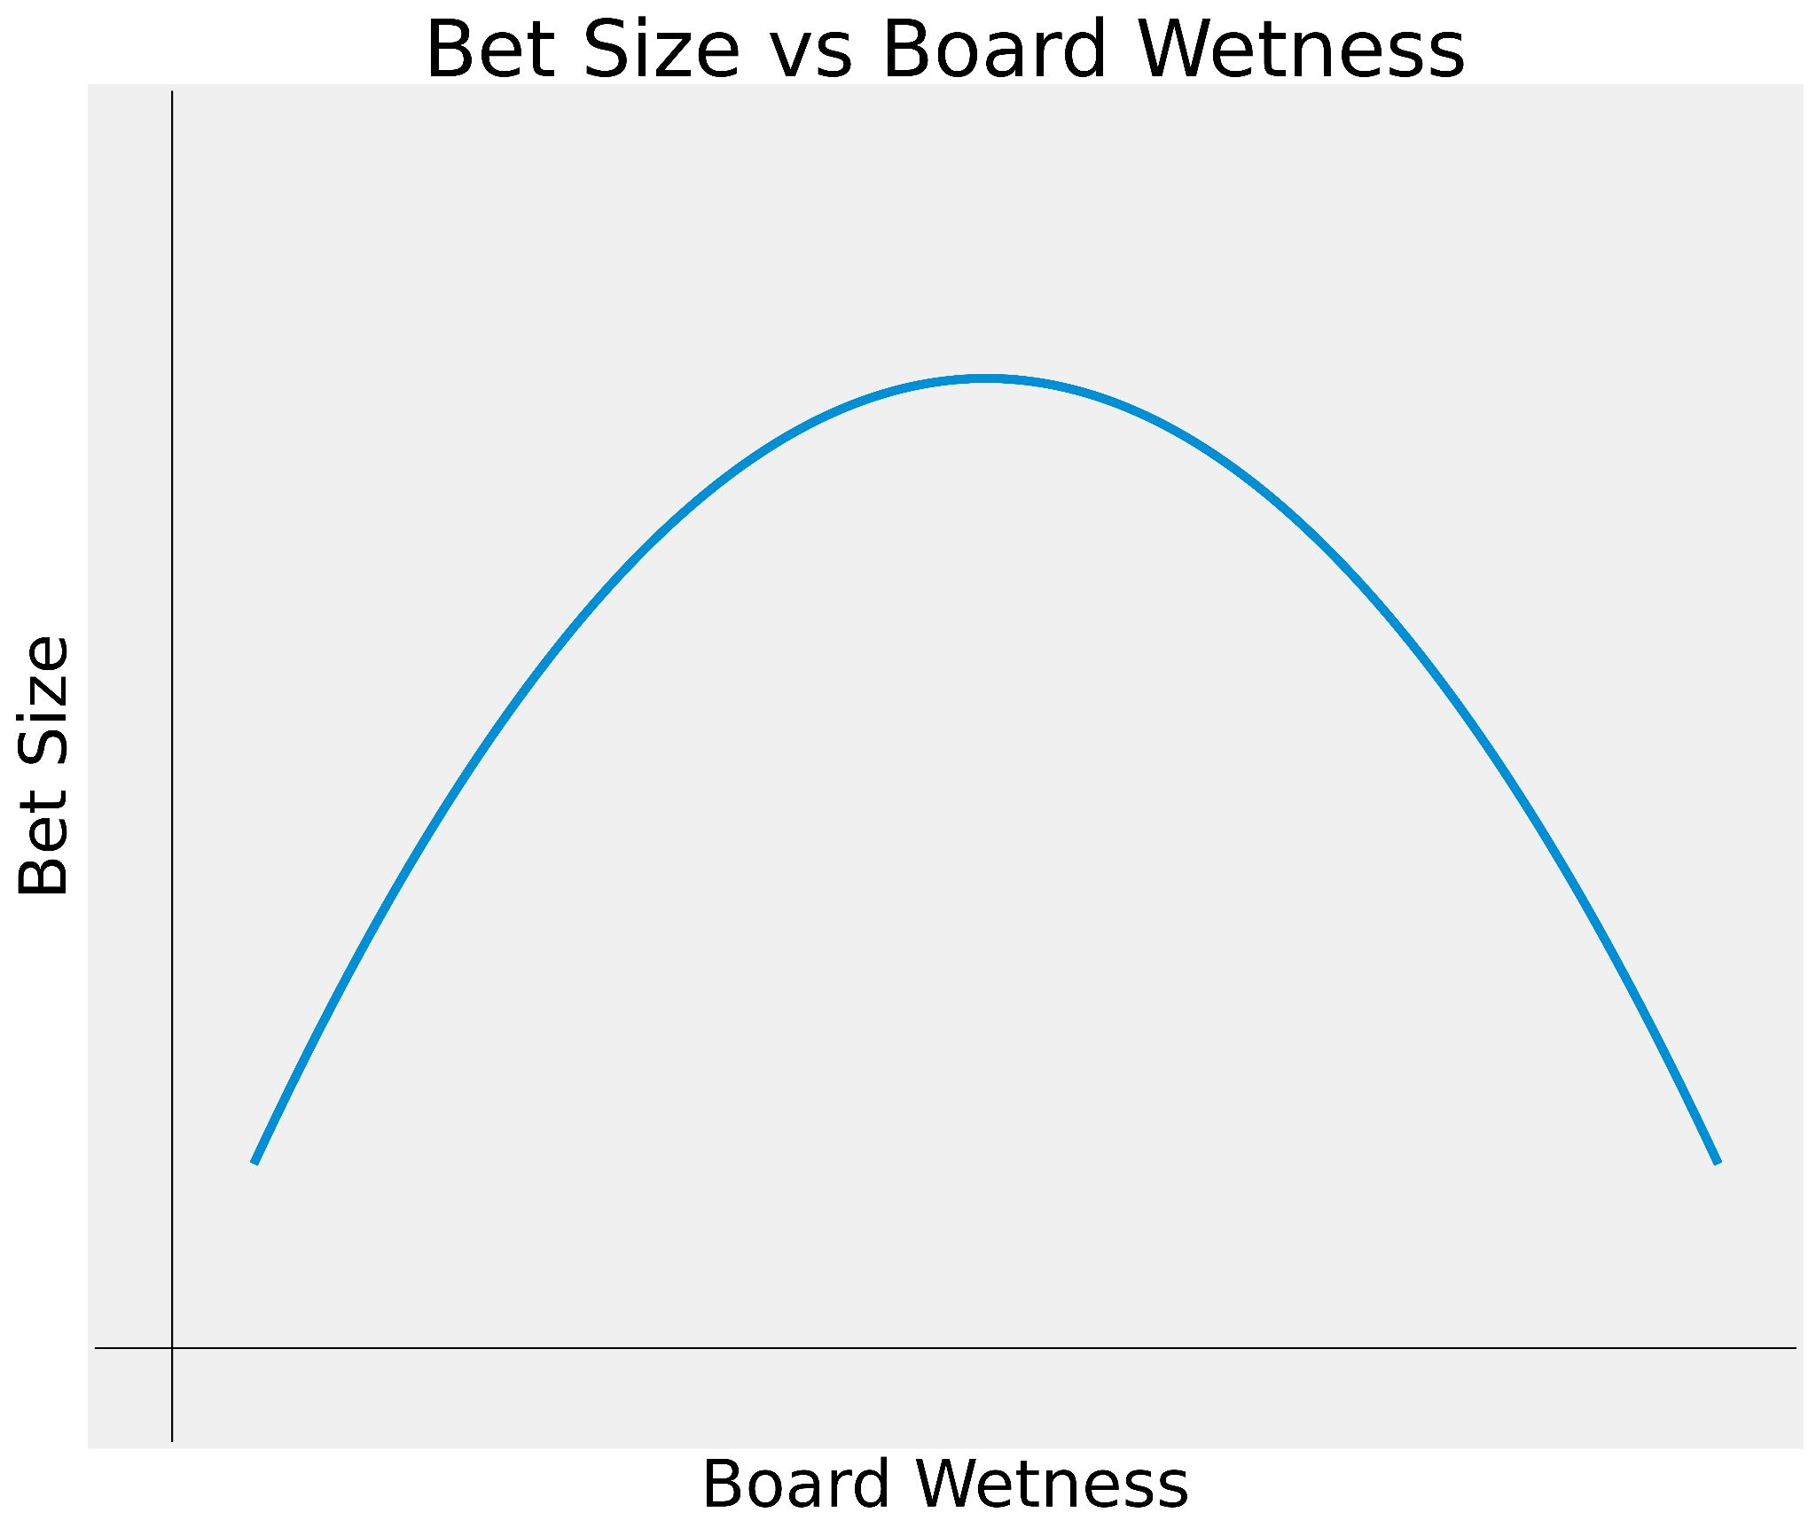

Board Texture Exercise

● Two flush draws

● Several straight draws: 9T, TJ, AJ

● Board is wet, we don’t want opponents to complete their draws cheaply

● Go all-in!

**2.4 Ranges**

We know the pot odds when faced with any bet

* If we can estimate P better than our opponent, then we will make money on

average

* What affects P?

Factors of win probability

* Bluffing
* Betting style
* Board and Hole cards
* Ranges

Our opponent’s range is the distribution of hands we expect them to hold

Which ranges are good?

* Tight-aggressive
* Fold early and often to mitigate losses
* Bet and win when you have a good hand!

Example ranges:

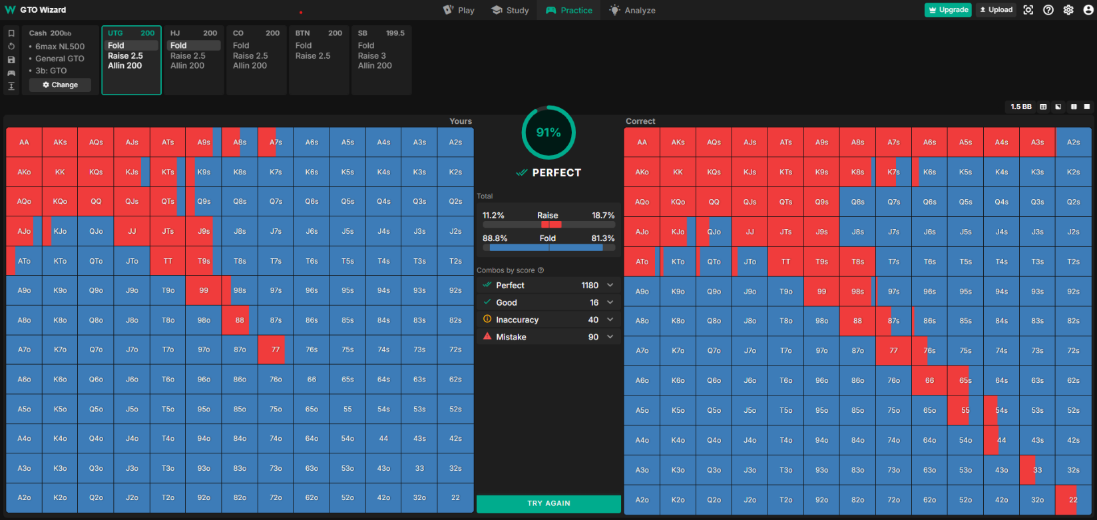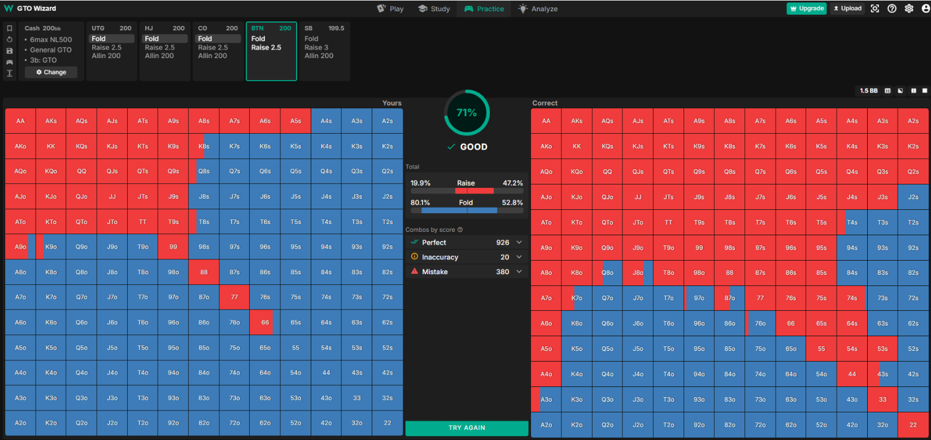

**2.5 What is Probability?**

* We say “probability of [event] happening is x”
* x is usually a number from 0 to 1 or a percent
* But what does x’s value mean?

**Interpretations of Probability**

Frequentist

* How often an event occurs over repeated trials
* Ex: When rolling a dice repeatedly, we notice 1/6th of rolls are a 2
* What about events that aren’t repeated? Eg: 2024 election

Subjectivist (Bayesian)

* Degree of belief, or ‘credence’ of an event occurring from the perspective of an individual with a given set of information
* Different pieces of information ‘update’ the probability to be higher or lower depending on how much evidence they provide for the event
* However, this requires some assumptions for which default probability values to start with before any updates

This is mostly a philosophical question within epistemology. Regardless of interpretation, probability is used as a quantitative metric for modeling uncertainty in things we don’t know

**Motivation: Finite Possibilities with Equal Chance**

* Wish to find/define probability of some event that occurs in some outcomes
* An intuitive definition: Probability of event = (# favorable outcomes) / (# total outcomes)
* Ex: Randomly draw card from standard deck, probability of Spades
  + 13 cards with spades
  + 52 cards total
  + 13/52 → ¼
* This reduces any question of probability into a counting problem
* What about outcomes with unequal chance?
* Or infinite outcomes? (e.g. continuous spectrum of possibilities)
* We need some general way to define their events and probabilities

**2.6 Kolmogorov Axioms**

* Events are viewed as sets of outcomes, and every set is a subset of the largest set Ω, which can be viewed as the ‘universal’ set encompassing all outcomes. We define a function P to give the probability of an outcome falling within an event set , satisfying the following axioms:
* 1. P(Ω) = 1
* 2. P(E) ≥ 0 for any event set E
* 3. P(A ∪ B) = P(A) + P(B) for any disjoint (aka nonoverlapping) event sets A, B

These axioms can prove all other results which we’d expect to make sense:

* If A ⊆ B, then P(A) ≤ P(B)
* P(empty set) = 0
* P(E) ≤ 1
* P(Ω - E) = 1 - P(E)

As long as we can define a universal set Ω and an idea of probability that follows the axioms, then we can use any of the results.

**Kolmogorov Axiom Example**

Consider you have a six-sided die manufactured so that “one”, “two”, and “three” turn up twice as often as the other outcomes.

When rolling this die, what is the probability of getting an odd number?

What is the probability of getting an even number?

Say you observe that when your opponent raises from early position (EP), they showdown with specific hands types with these frequencies:

Axiom 1: Non-negative probability

* P(Premium pairs: AA, KK, QQ) = 0.4
* P(Strong Ax hands: AK, AQ) = 0.3
* P(Medium pairs: JJ, TT, 99) = 0.2
* P(Bluffs/other hands) = 0.1
* All probabilities are ≥ 0

Axiom 2: Total probability equals 1

* P(All possible hands) = 0.4 + 0.3 + 0.2 + 0.1 = 1

Axiom 3: Additive for mutually exclusive events

* P(Premium pairs OR Strong Ax) = P(Premium pairs) + P(Strong Ax) = 0.4 + 0.3 = 0.7

Conditional Probability Example:

* P(Opponent has AA | Opponent raises EP) = P(Opponent raises EP with AA) / P(Opponent raises EP)
* If P(Opponent raises EP with AA) = 0.15 and P(Opponent raises EP) = 0.2
* Then P(Opponent has AA | Opponent raises EP) = 0.15/0.2 = 0.75. This tells us when this particular opponent raises from early position, they hold pocket aces 75% of the time.

Suppose opponent 3-bets all-in after your raise:

* P(AA | All-in) = (P(All-in | AA) × P(AA)) / P(All-in)
* When an opponent moves all-in after your raise, Bayes' Theorem provides a framework to update your prior beliefs about their holdings.
* If P(All-in | AA) = 0.9, P(AA) = 0.02, P(All-in) = 0.05
* Then P(AA | All-in) = (0.9 × 0.02) / 0.05 = 0.36
* The calculation P(AA | All-in) = (0.9 × 0.02) / 0.05 = 0.36 shows that while pocket aces only represent 2% of all possible hands, the probability jumps to 36% when your opponent shoves all-in.
* This dramatic increase occurs because we've incorporated new evidence (the all-in move) and recalculated the probability given this specific action, which aces players take 90% of the time.

Takeaway:

* probability of an event increases when you observe evidence that makes it more likely
* Conditional probabilities allow us to mathematically represent this effect, which is called Bayes’ Theorem

**2.7 Random Variable & Distributions**

* A random variable is a quantity or event which takes on different values with different probabilities
  + Ex: A drawn card that’s face down and hasn’t been turned over
* The set of possible values it can take on would represent the universal set of events for probabilities concerning this variable.
  + Ex: 52 total cards that our mystery card could have
* Any event concerning this variable corresponds to set possible values it takes on
  + Ex: “card is black” <--> set of 26 cards
* Distributions are functions that are used to define probabilities for different events
* For discrete events, this is called a “probability mass function” (think bar graph)
* For continuous events, this is called a “probability density function” (think histogram)

**2.8** **Variance**

* If expected value describes where random variable “usually” is, then variance measures how much the random variable may fluctuate
* This is done by finding the average squared distance from the mean:
  + Random variable X with E[X] = μ
  + → Var[X] = E[(X - μ)^2]
* Standard deviation is a similar measurement, which is simply the square root of variance To Summarize:
* Expected Value is the average of a random variable and is often used as a “best guess” for the result
* Variance and standard deviation are used to measure how close this guess would generally be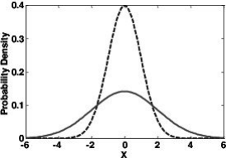

**2.9 Law of Large Numbers**

* X is a random variable with mean μ with some distribution
* Independent samples X1 , X2 , … Xn are drawn from the distribution.
* “Sample mean” X̄ is the average of these samples.
* It can be shown that E[X̄] = μ and Var[X̄] = Var[X]/n
* The law of large numbers states that this sample mean X̄ is guaranteed to approach the actual mean μ as n (the number of samples) approaches infinity Law of Large Numbers
* This gives us another intuitive way to think of the mean - the average of infinite hypothetical trials
* The law of large numbers also conveys a powerful idea: with enough data points, you can accurately estimate properties of random processes, even if their underlying distributions are unknown
* With the ability of computation, certain quantities are now much easier to compute

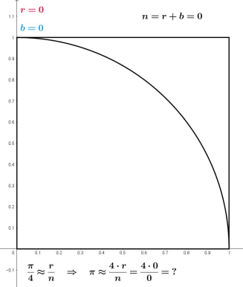

**2.10 Monte Carlo Simulation**

* Style of computational methods to calculate a result using repeated random sampling and averaging (aka a direct application of LLN)
* Ex: estimating area using geometric probability Monte Carlo Estimation
* Another example is the way we run Pokerbots matches!
* Dividing the cumulative deltas by 1000 is a Monte Carlo estimate for the expected number of chips gained in a single round
* Therefore a good pokerbot should try to maximize the expected number of chips earned within a single hand